**TASK -5**

**Objectives**

* Explain how to clean up and push back to remote Git

In this hands-on lab, you will learn how to:

* Execute steps involving clean up and push back to remote Git.

Step-1 Verify master is in clean state

git checkout main

git status

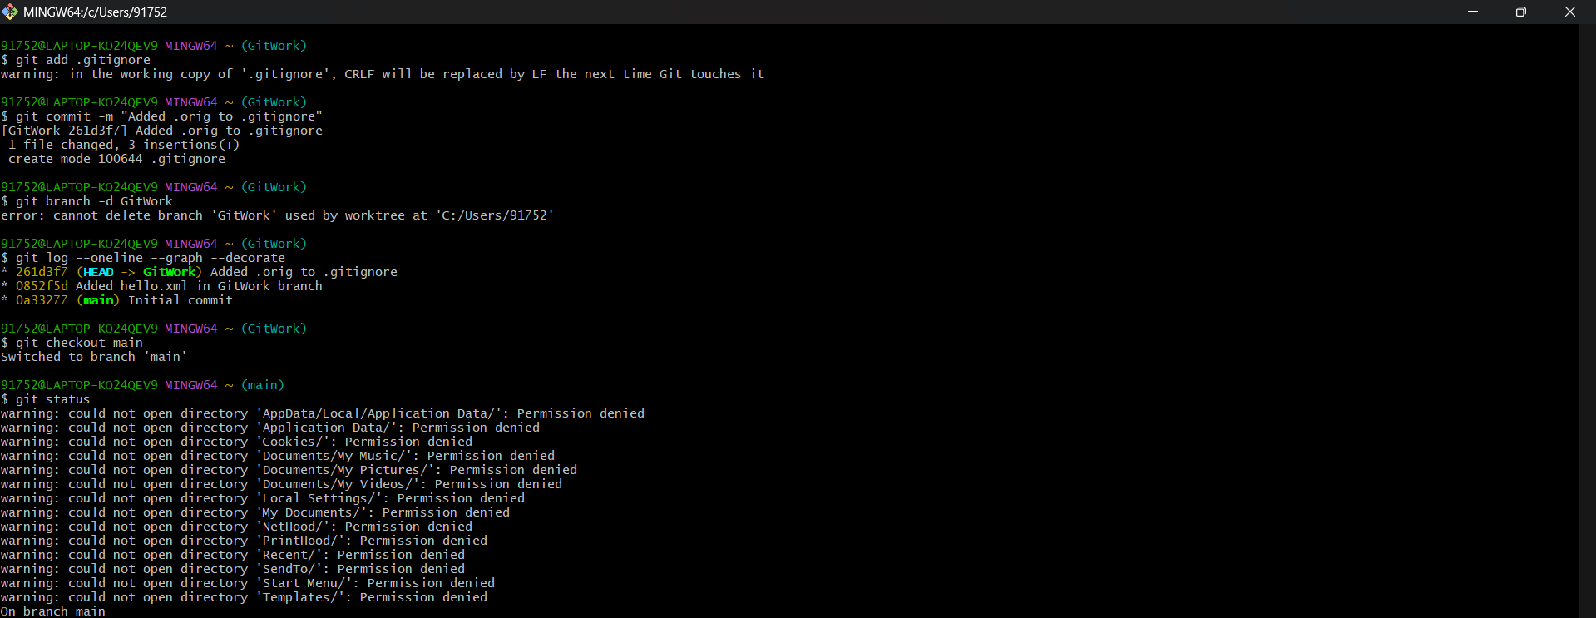

Step 2- List all available branches

git branch -a

Step -3 Pull from remote repository to master

git pull origin main

Step-4 Push pending changes from local to remote

git push origin main

